Hackathon 2016

SCORING APPLICATION

Use-Case By H&R Block



**TEAM**: Tech-Knights

**Members**::

Aishvwarya Natarajan Iyer

Gayathree Natarajan Iyer

Sruthi Gelivi

Pranathi Gopidi

**Introduction**

‘Scoring Application’ can be used by future judges of Hackathon events where judges will be able to score the teams more efficiently and hassle-free.

This ‘Scoring Application’ is user friendly and simple to score and manage the teams participating in Hackathon.

There are 2 users:

Judges

Admin

Both Judge and Admin can login to this scoring web-application to have different access rights to the web application.

**Roles of Judge**

* Judge needs to REGISTER by providing details like his First name, Last name, Company name, Email-Id, Password and Confirm Password.
* Judge can login into the web-application with his email-id and password.
* Judge can give scores to the teams based on various factors like User Experience, Collaboration, Innovation, Code Quality, Originality, Design, Functionality and Integration of Technology.
* Judge can give comments to the teams based on their performance.
* Judge can update the scores of teams throughout the event.
* Judge can disqualify the team in case of cheating.
* Judge can have Bar-Chart view of the final result.

**Roles of Admin**

* Admin can Login into the web-application.
* Admin can Add a new team.
* Admin can Delete a team.
* Admin can have the Bar-chart view of the final result.

**Registration**

Judge can register in the web application using First name, Last name, Company name, Email Id, Password and Confirm Password.

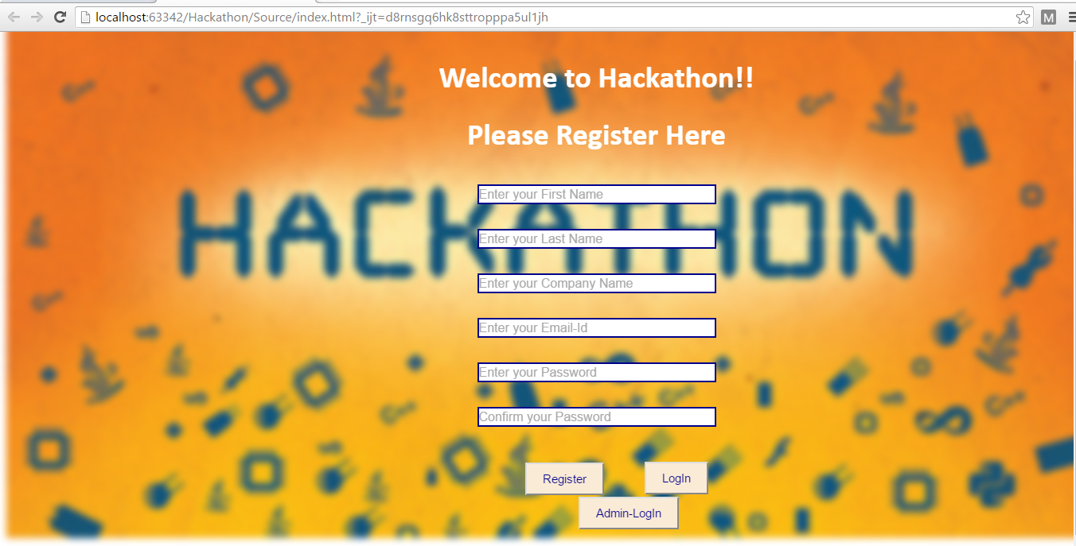

**Invalid Email-Id**

Judge should enter valid email address otherwise there will be an error message.

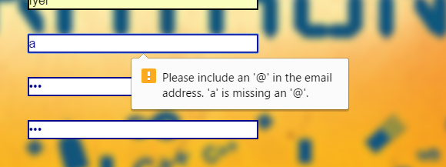

**Login Page**

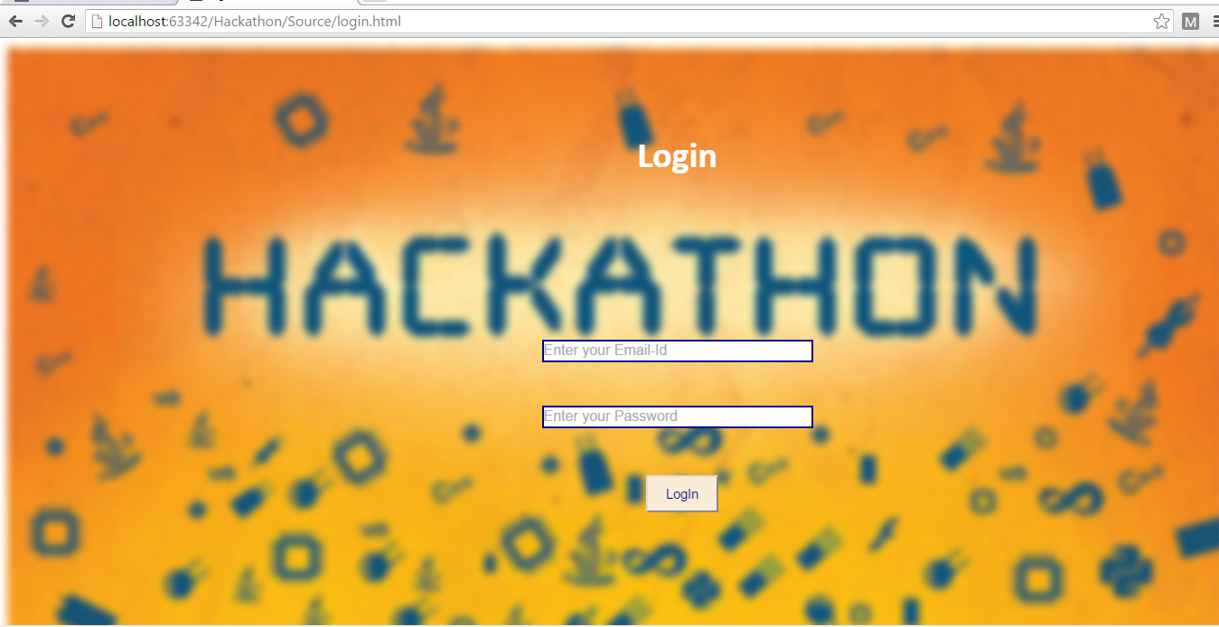

**Scores Page**

Judge can give scores and comments to the teams based on various criteria.

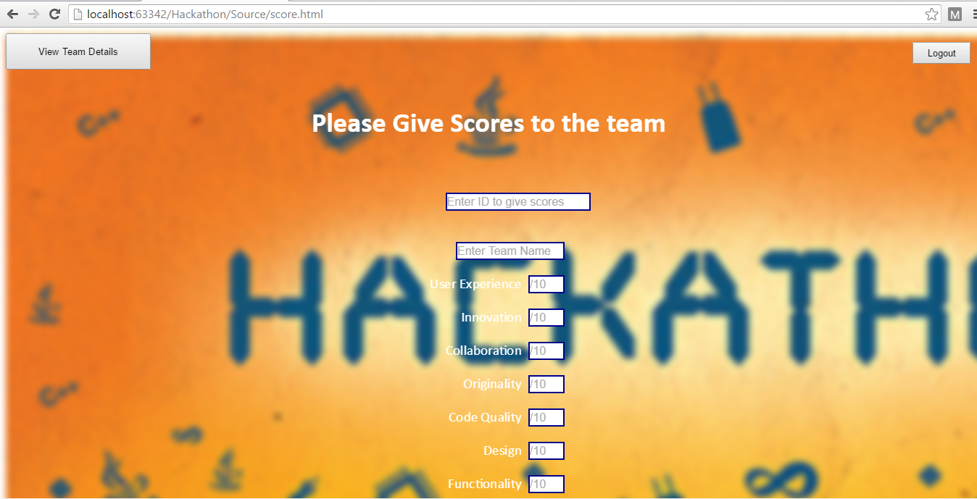



**Allocation of Scores By Judges**

Judge have entered scores to Team- TeamKnights.The total score is calculated automatically as the judge give scores to each criteria. The judge can enter the final calculated score and comment about the team performance.

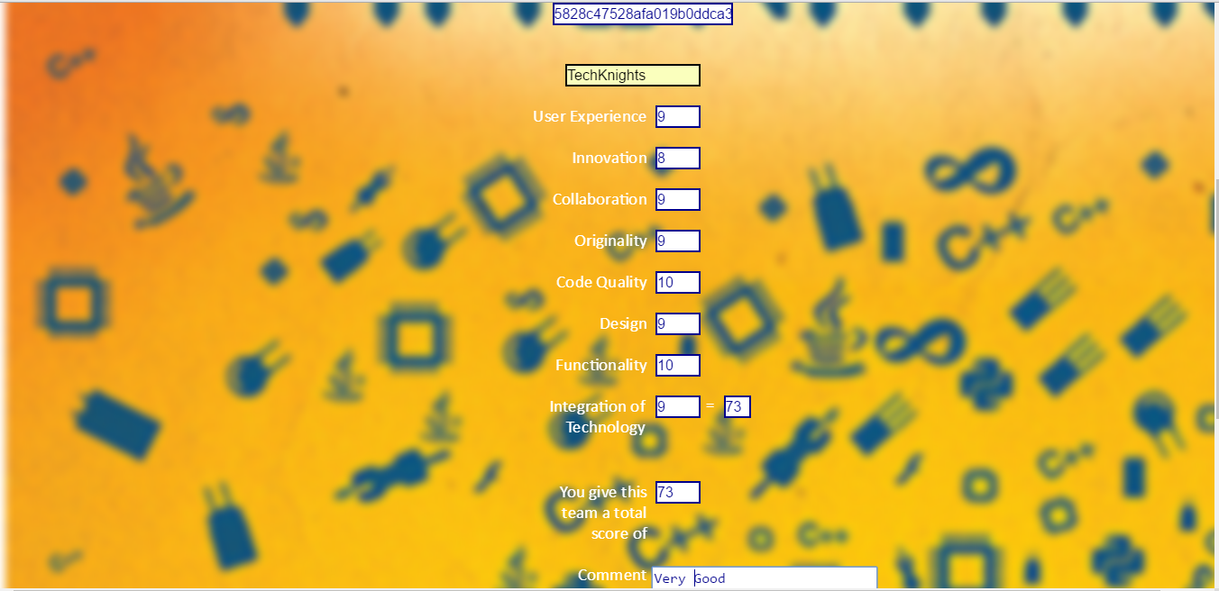

**View Team Details After Giving Scores**

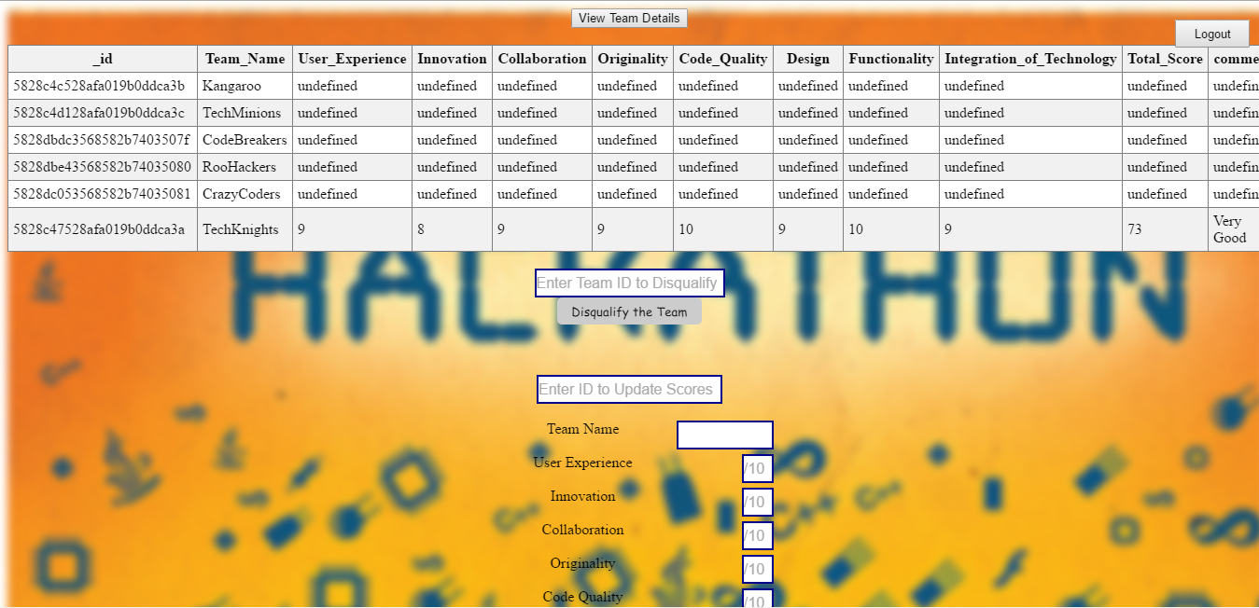

The judge can click on ‘View Team Details’ to get the complete list of teams, their scores and comments. The teams that are yet to be judged and given scores are ‘undefined’.

**Disqualify Team**

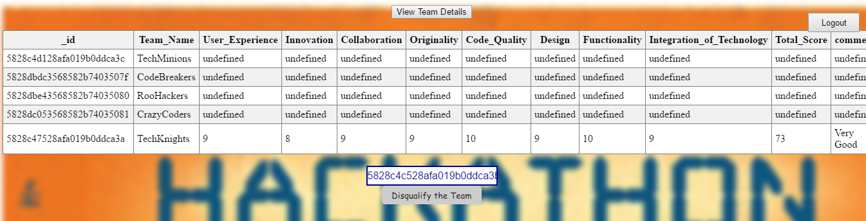

The judge can disqualify a team in case the judge wants to disqualify a team. The judge can do so by entering the team Id.

**Update Scores of a Team**

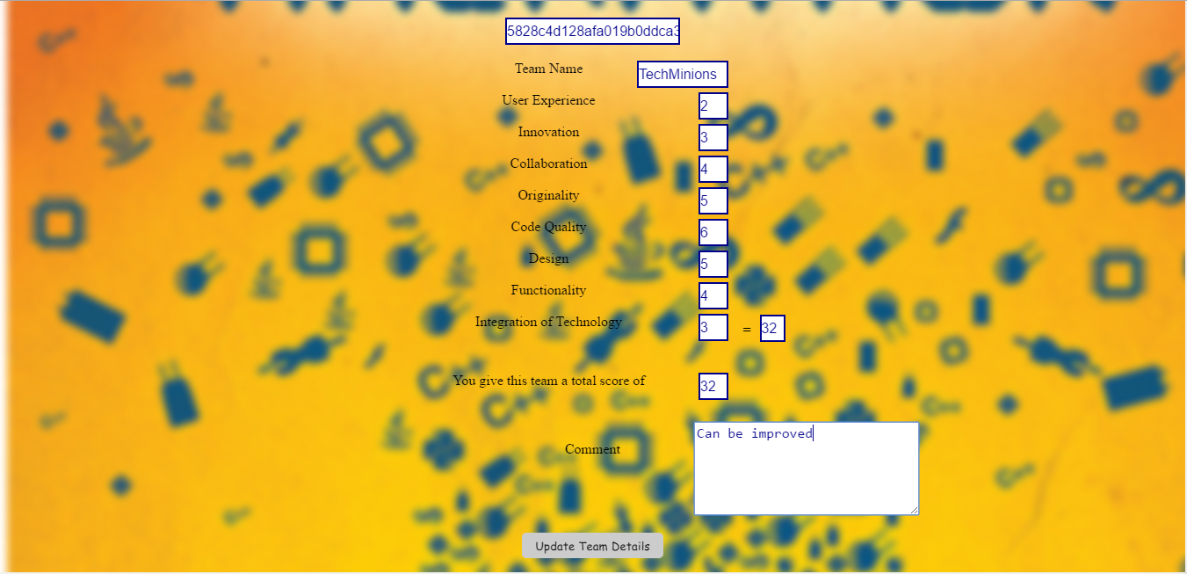

The judge can update the scores of a particular team by entering the team ID and team name. The Judge will enter new scores and comments for the team. Here, the judge is updating the scores for team: ‘TechMinions’.

**Scores Updated**

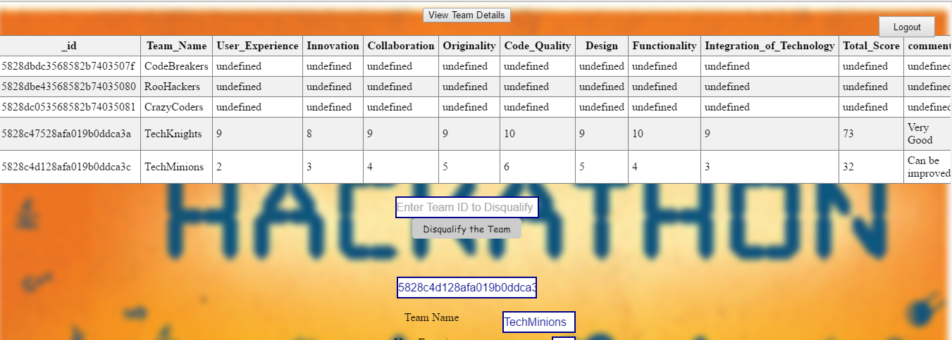

The judge can view the updated scores by clicking on ‘View Team Details’. Here, the scores of TechMinions have been updated.

**Final Result**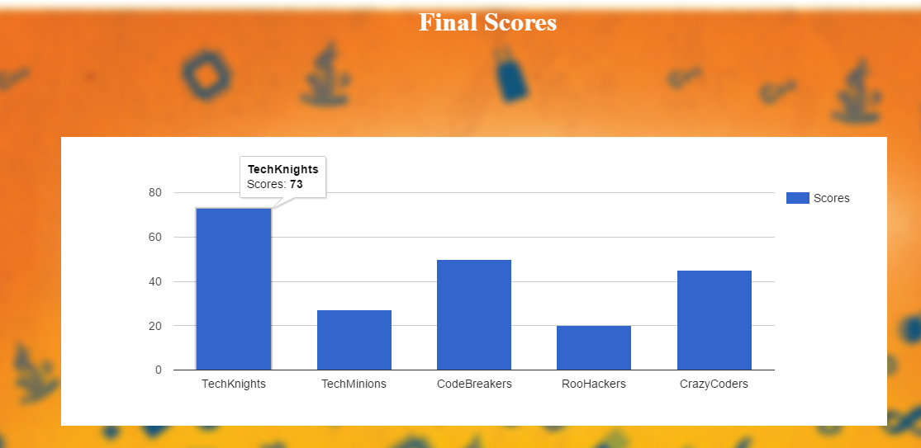

Similarly, the judge will give scores to all the teams. Final Result are visible in Bar-Chart using Google Chart API. When we move the cursor on top of the bar, judge can see the final calculated score of that particular team.

**Admin View of Scoring Web-Application**

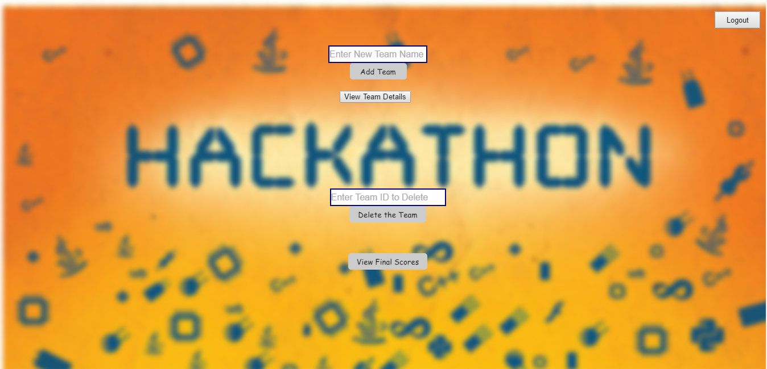

Admin can login into the scoring web-application. The admin will then be directed to the above page where admin can either add or delete a team. Admin can also view final scores of all the teams.

**Add New Team- by Admin**



Admin here adds a new team- ‘Zeristos’ and then clicks on ‘Add Team’ button.

**New Team Added**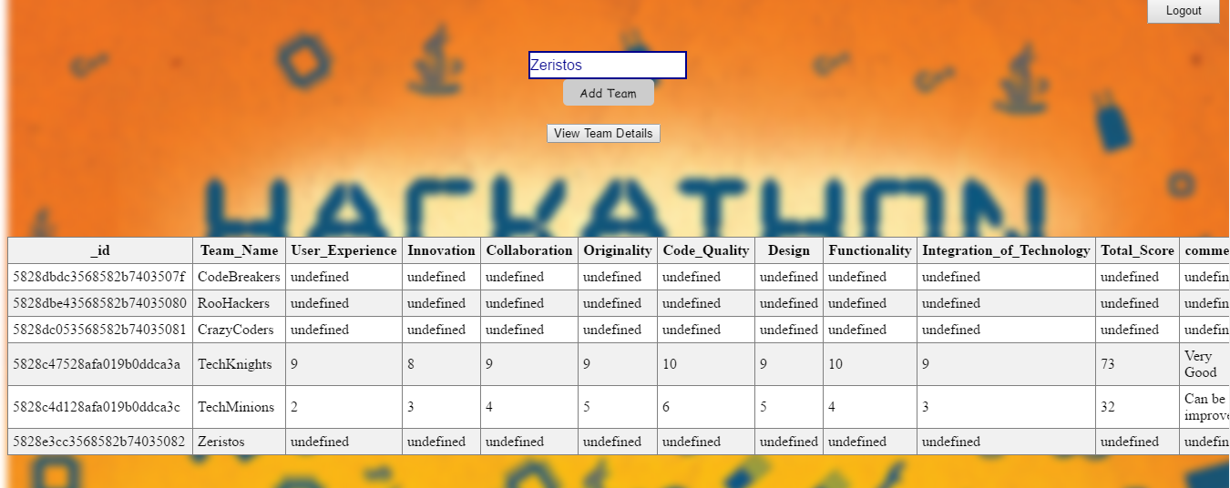

Upon clicking on ‘View team details’ button, the admin can see the new team displayed in the table with scores yet to be assigned.

**Delete Team- by Admin**

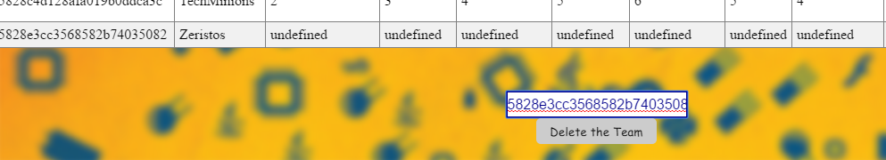

The admin can enter the team ID to delete a particular team and then click on ‘Delete the Team ’ button.

**Team Deleted**

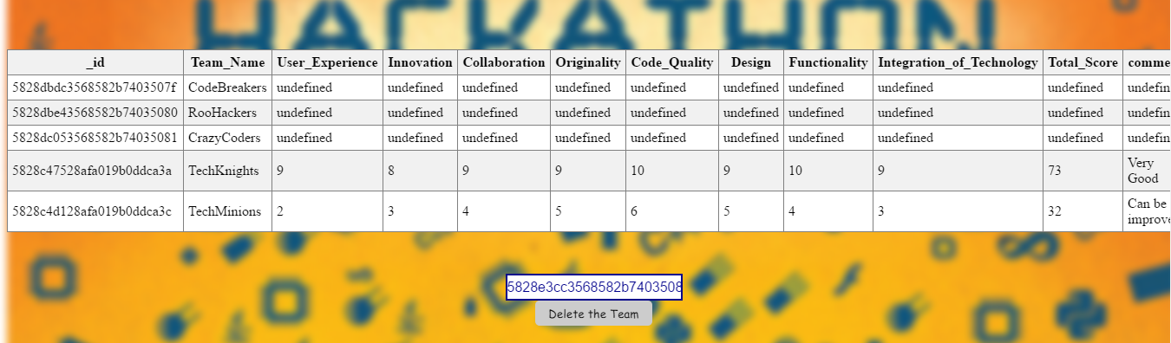

The judge can notice that team-‘Zeristos’ has been deleted.

**Final Results view by Admin**



The admin can view the final scores of all the teams.

**MongoDB- Database**

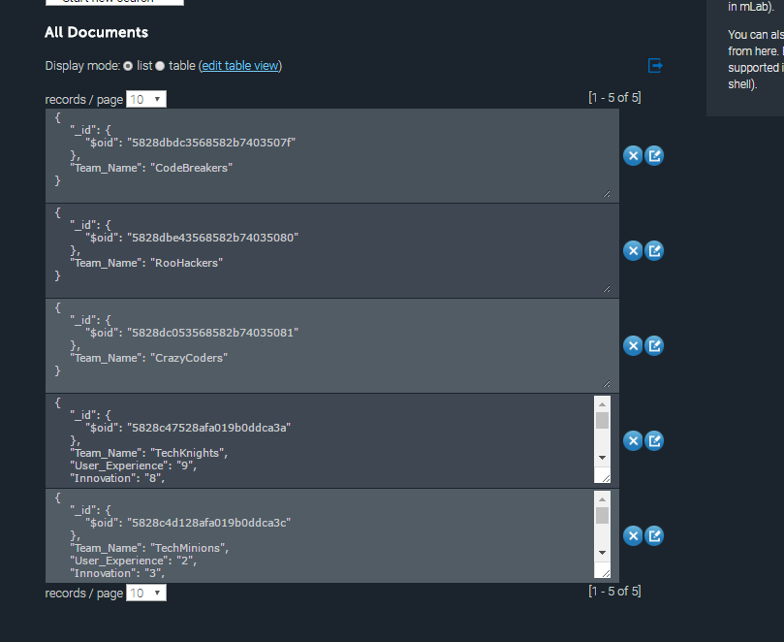

This is MongoDB database with collection ‘Hackathon’ and all the team details with scores and comments.